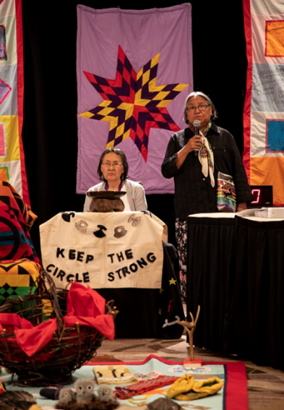
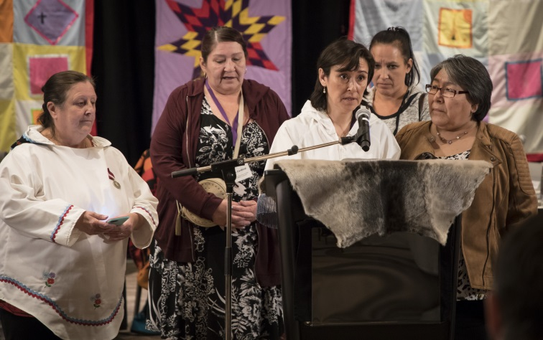

Thank you to the people of Treaty 7 Territory and the Metis Nation in Region 3 for the warm welcome and hospitality they provided to the National Inquiry into Missing and Murdered Indigenous Women and Girls during the Institutional Hearing on Government Services held in Calgary from May 28 to June 1, 2018.

Thank you as well to the Elders, Grandmothers, Traditional Knowledge Keepers, members of the National Family Advisory Circle, witnesses, and Parties with Standing who helped the National Inquiry better understand how a lack of access to government and institutional services can exacerbate the risks that Indigenous women and girls face in remote communities, and can create additional challenges for vulnerable individuals and communities.

The testimony that was shared in Calgary shed important light on how government services – whether they are victim and justice services; family violence prevention services; or health, addictions or mental health services – often struggle with service delivery, particularly in northern and remote communities, and how many front line workers work tirelessly to support indigenous women and girls, often under extremely trying circumstances.

The Calgary hearings greatly informed the National Inquiry’s understanding of the systemic factors that combine to place Indigenous women and girls at risk, and we look forward to receiving additional testimony at our next events, which are scheduled as follows:

June 11 to June 13, 2018. The National Inquiry will be in Toronto for the third Knowledge Keeper and Expert Hearing on Racism. This Hearing will explore the racism and discrimination that creates vulnerable circumstances and increases violence for Indigenous women, girls and 2SLGBTQ people. The Hearing will also look at solutions, practices and policies that combat racism and create safer spaces and services.

June 25 to June 29, 2018. The National Inquiry will be in Regina for the second Institutional, this one focused on police policies and practices. This Hearing will focus on how police respond to violence against Indigenous women, girls and 2SLGBTQ people and will include an examination of some of the policing policies and practices that guide investigation processes.

National Inquiry Hearings are open to the public and help to frame the recommendations that will be included in the National Inquiry Final Report. Learn how you can watch the National Inquiry hearings at: http://www.mmiwg-ffada.ca/

Together we will find the truth, honour the truth, and give life to the truth.

