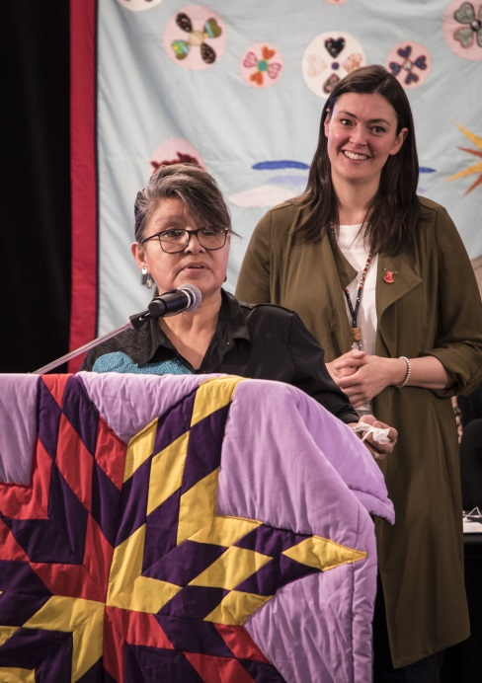
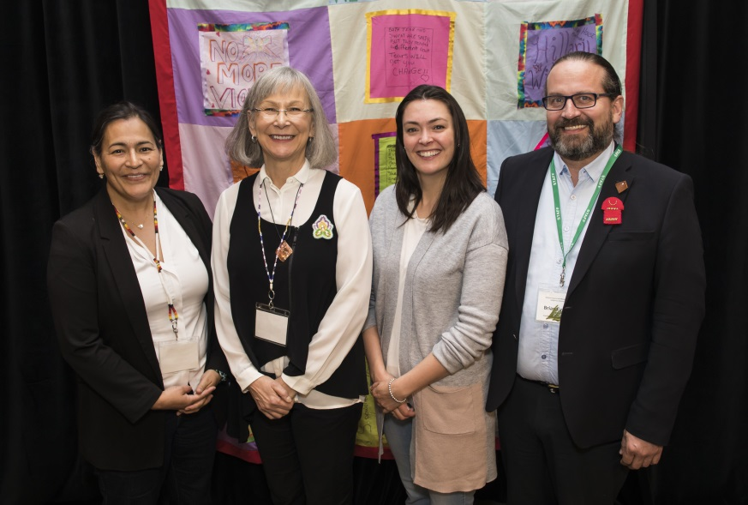
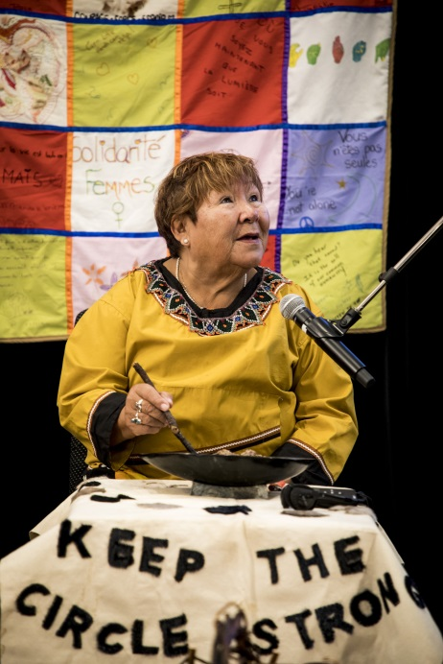

Tiawenhk! Merci! Thank You!
Tshinaskumitnau! Chi-Miigwetch! Nakurmiik!

Thank you to the Wendat people for welcoming the National Inquiry to your territory for the Human Rights Framework Knowledge Keeper and Expert Hearing in Quebec City, from May 14 – 17, 2018.
Thank you also to the Elders, Grandmothers and Women Warriors, Witnesses and all Parties with Standing for attending, participating and further contextualizing the work of the National Inquiry into Missing and Murdered Indigenous Women and Girls.
The Knowledge Keepers and Expert hearings (Part III) and Institutional hearings (Part II) have been well prepared by the more than 1200 testimonies shared by family members and survivors with the National Inquiry. Their troubling and heartbreaking truths have shaped and created the foundation for Part II and Part III hearings. Thank you to family members and survivors for gifting us with a sacred responsibility.
Last week, the witnesses presented powerful tools, such as international instruments and social determinants of health, that can inform the work of the National Inquiry and build a Human Rights Framework that includes a gendered lens, is substantively rights based and intersectional, as well as culturally specific and decolonizing. Beyond these tools, a reflection on the important role of men in ending the cycle of violence was also brought as compelling evidence. Men need to be part of the solution and need to walk beside the women and girls in our communities and honour, respect and support them. The Quebec City Hearing strengthen the National Inquiry’s examination of the systemic causes of violence, and will inform the final report and recommendations.
May 28 to June 1, 2018, the Commissioners will be in Calgary for the National Inquiry’s first Institutional Hearing on Government Services, and specifically on victim services, health including mental health, addiction services and treatment in remote Indigenous communities, and housing including emergency housing, shelters and safe houses.
June 11 to June 13, 2018, the National Inquiry will be in Toronto for the third Knowledge Keeper and Expert Hearing on Racism. This Hearing will explore the racism and discrimination that creates vulnerable circumstances and increases violence for Indigenous women, girls and 2SLGBTQ people. The Hearing will also look at solutions, practices and policies that combat racism and create safer spaces and services.
On June 25 to June 29, 2018, the National Inquiry will be in Regina for the second Institutional Hearing on police policies and practices. This Hearing will focus on how police respond to violence against Indigenous women, girls and 2SLGBTQ people including policies and practices.
National Inquiry Hearings are open to the public.

